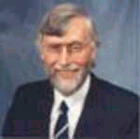
COUNCILLOR FOR WARD (16) Kelvingrove

Dr Malcolm Green
Spokesperson on European Affairs
Political Party : Scottish Labour Party
Council Phone No. 0141 287 4515
E-mail : malcolm.green@councillors.glasgow.gov.uk Address : Glasgow City Council, City Chambers, George Square, Glasgow, G2 1DU

